Bootstrapping Issues

Comparing between Segment Intervals
ETF Watersheds
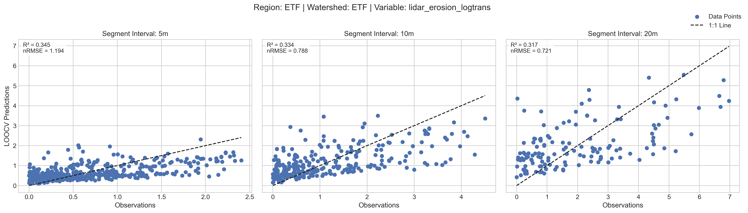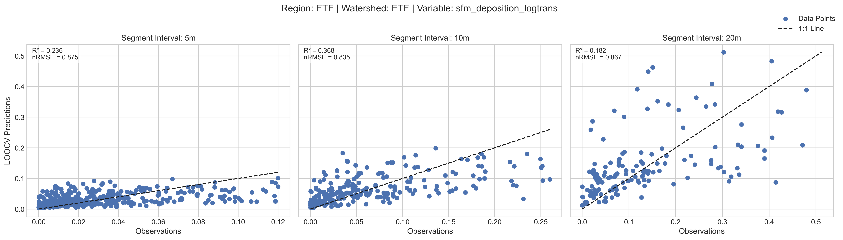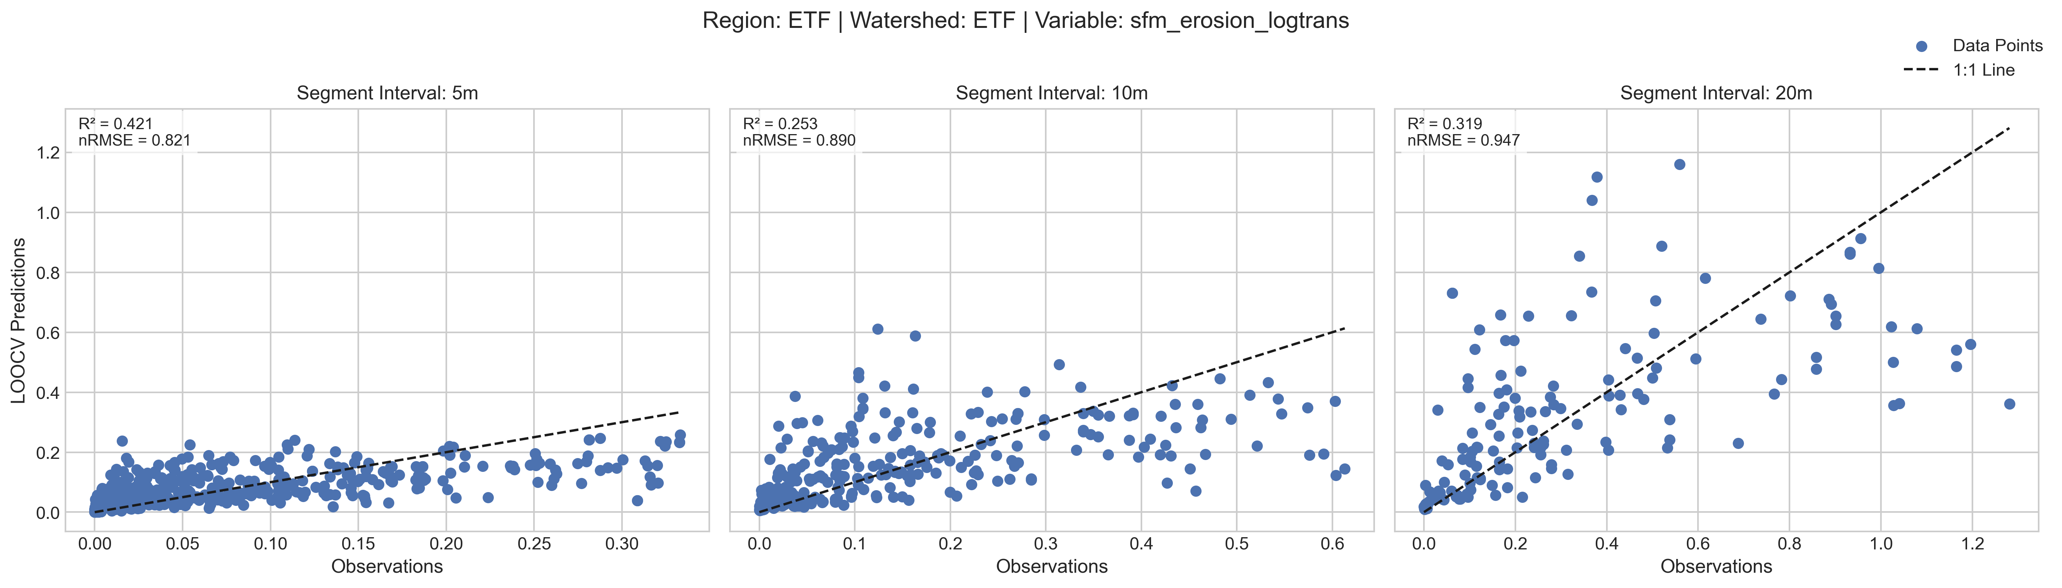

CPF Watersheds
